Test Case: tc003_SPX_Dev5_Crear_Requisicion_Spot_Tipo_Cobro_CC_Urgent
Step 1 - Enter username and password and click to button Enter : Credentials Entered
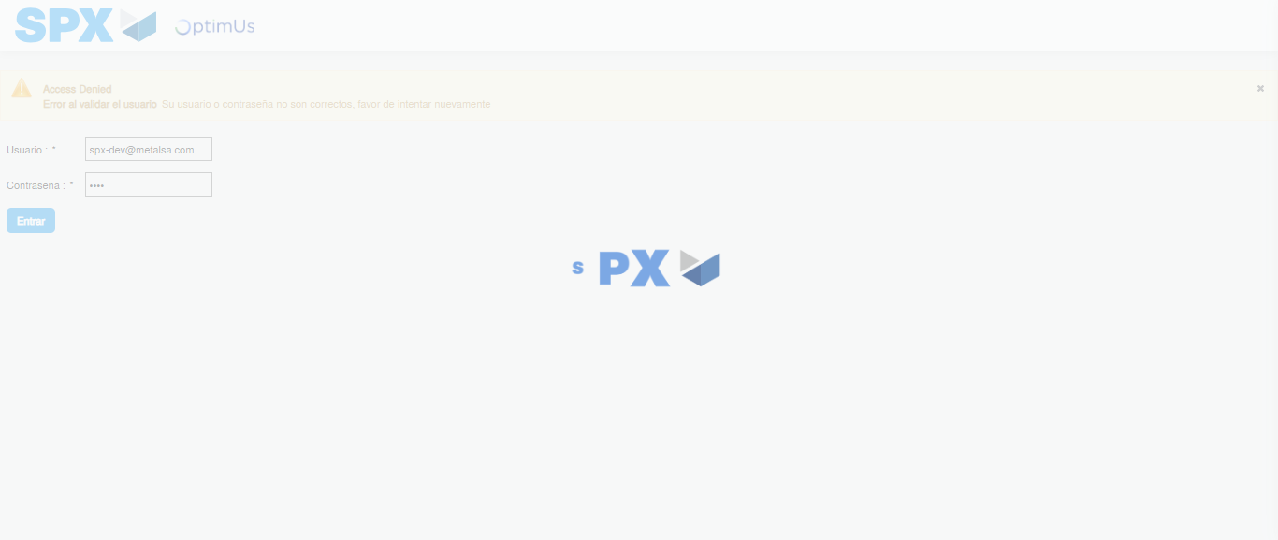Image file-name: QC_Testing-tc003_SPX_Dev5_Crear_Requisicion_Spot_Tipo_Cobro_CC_Urgent-1785961232001

Step 2 - Select to UEN and Access to Spot Buy Requisitions : UEN Correctly selected and Correct access
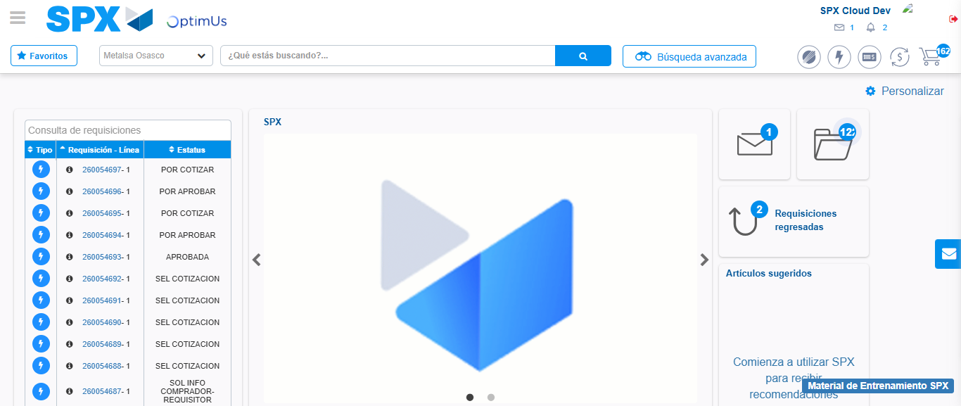Image file-name: QC_Testing-tc003_SPX_Dev5_Crear_Requisicion_Spot_Tipo_Cobro_CC_Urgent-1785961258007

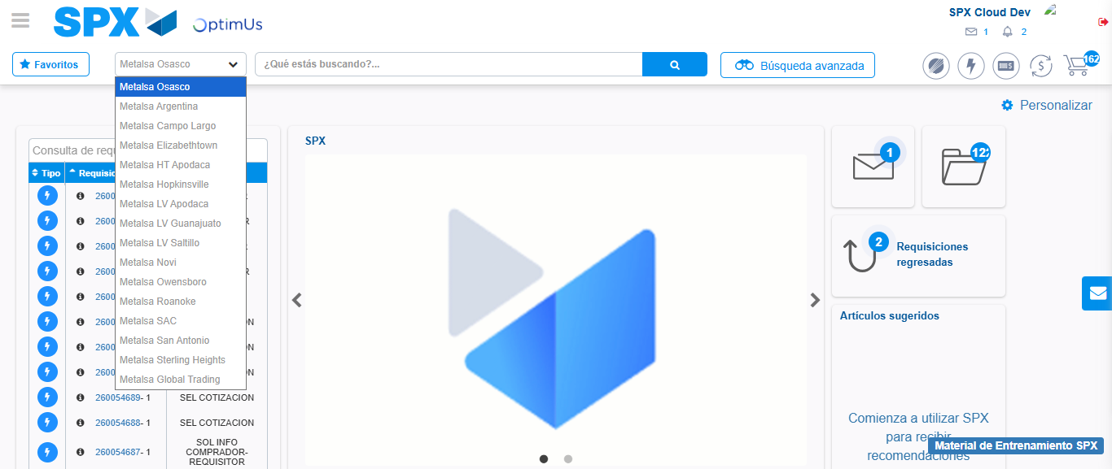Image file-name: QC_Testing-tc003_SPX_Dev5_Crear_Requisicion_Spot_Tipo_Cobro_CC_Urgent-1785961260642

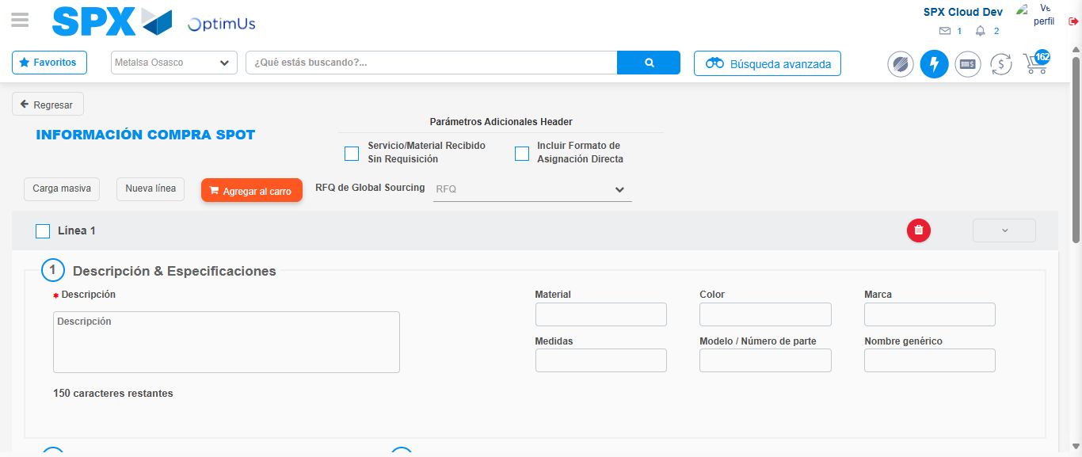Image file-name: QC_Testing-tc003_SPX_Dev5_Crear_Requisicion_Spot_Tipo_Cobro_CC_Urgent-1785961268892

Step 3 - Data Capture Spot Buy Requisition: Data captured correctly
Image file-name: QC_Testing-tc003_SPX_Dev5_Crear_Requisicion_Spot_Tipo_Cobro_CC_Urgent-1785961269133

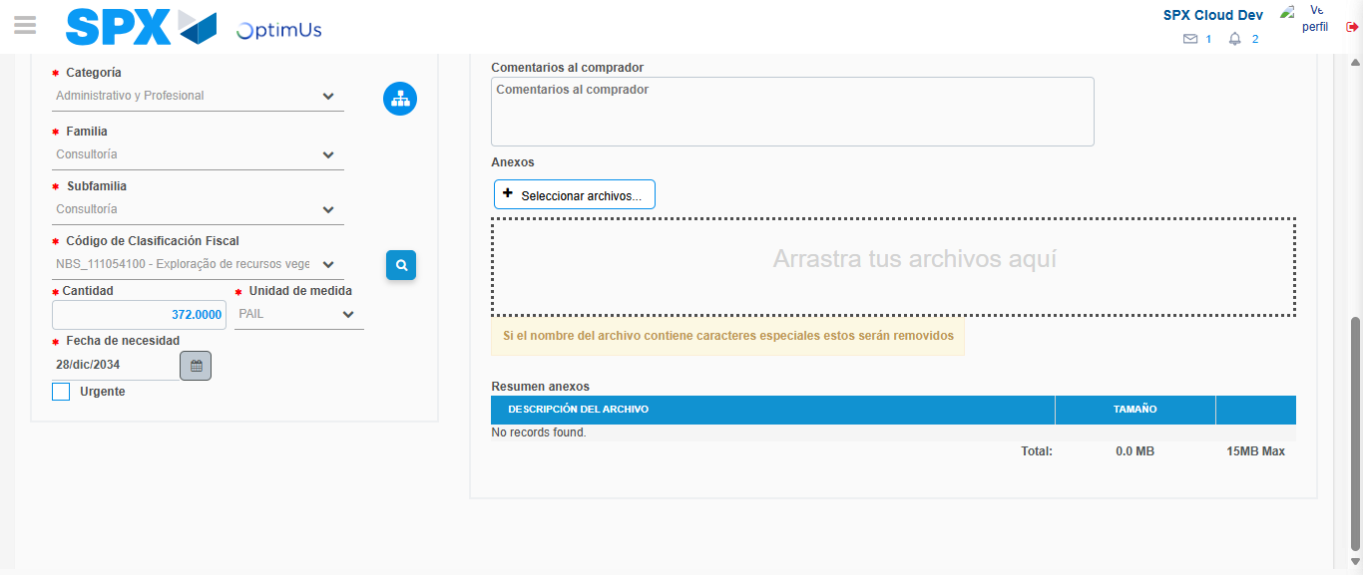Image file-name: QC_Testing-tc003_SPX_Dev5_Crear_Requisicion_Spot_Tipo_Cobro_CC_Urgent-1785961284289

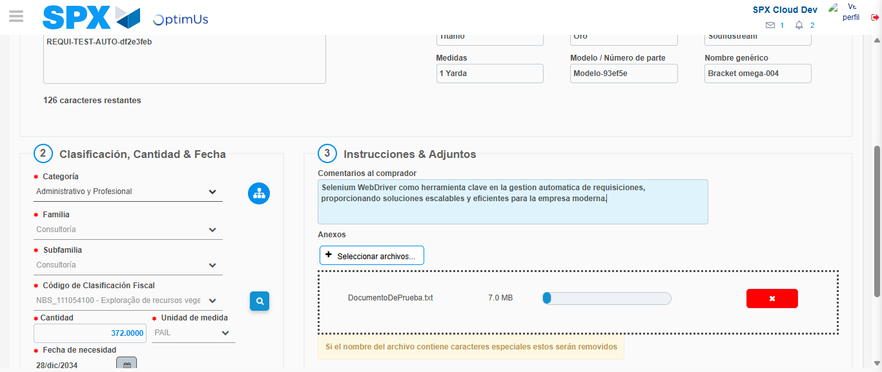Image file-name: QC_Testing-tc003_SPX_Dev5_Crear_Requisicion_Spot_Tipo_Cobro_CC_Urgent-1785961285087

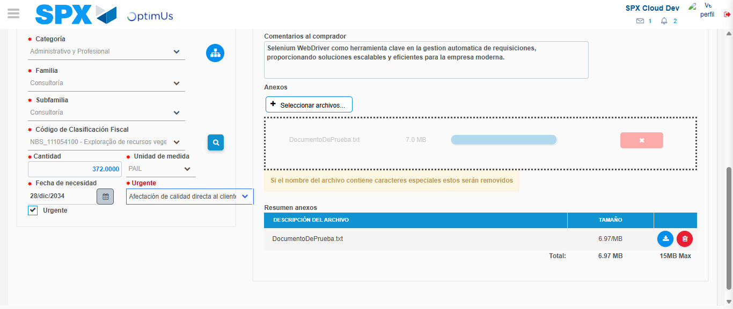Image file-name: QC_Testing-tc003_SPX_Dev5_Crear_Requisicion_Spot_Tipo_Cobro_CC_Urgent-1785961288782

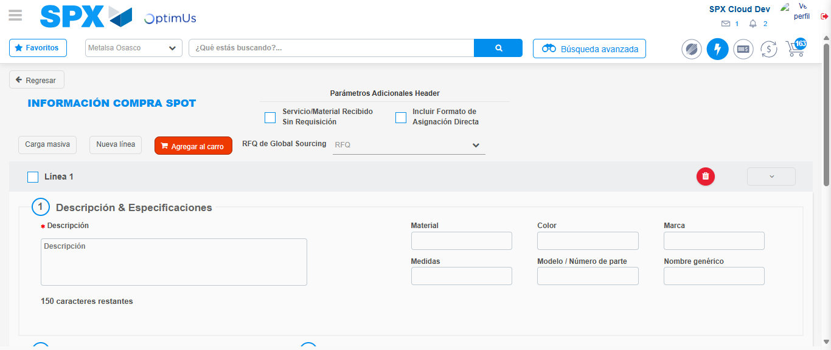Image file-name: QC_Testing-tc003_SPX_Dev5_Crear_Requisicion_Spot_Tipo_Cobro_CC_Urgent-1785961303374

Step 7 - Return to Main Page SPX : Return to Main Page SPX
Image file-name: QC_Testing-tc003_SPX_Dev5_Crear_Requisicion_Spot_Tipo_Cobro_CC_Urgent-1785961258007

Image file-name: QC_Testing-tc003_SPX_Dev5_Crear_Requisicion_Spot_Tipo_Cobro_CC_Urgent-1785961260642

Image file-name: QC_Testing-tc003_SPX_Dev5_Crear_Requisicion_Spot_Tipo_Cobro_CC_Urgent-1785961268892

Image file-name: QC_Testing-tc003_SPX_Dev5_Crear_Requisicion_Spot_Tipo_Cobro_CC_Urgent-1785961305634

Image file-name: QC_Testing-tc003_SPX_Dev5_Crear_Requisicion_Spot_Tipo_Cobro_CC_Urgent-1785961305827

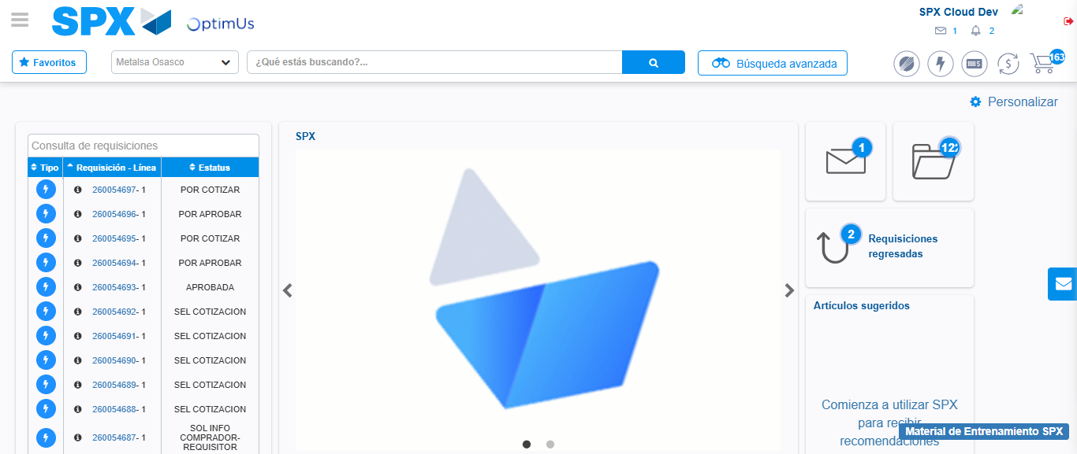Image file-name: QC_Testing-tc003_SPX_Dev5_Crear_Requisicion_Spot_Tipo_Cobro_CC_Urgent-1785961327113

Step 8 - Log Out : Log Out SPX
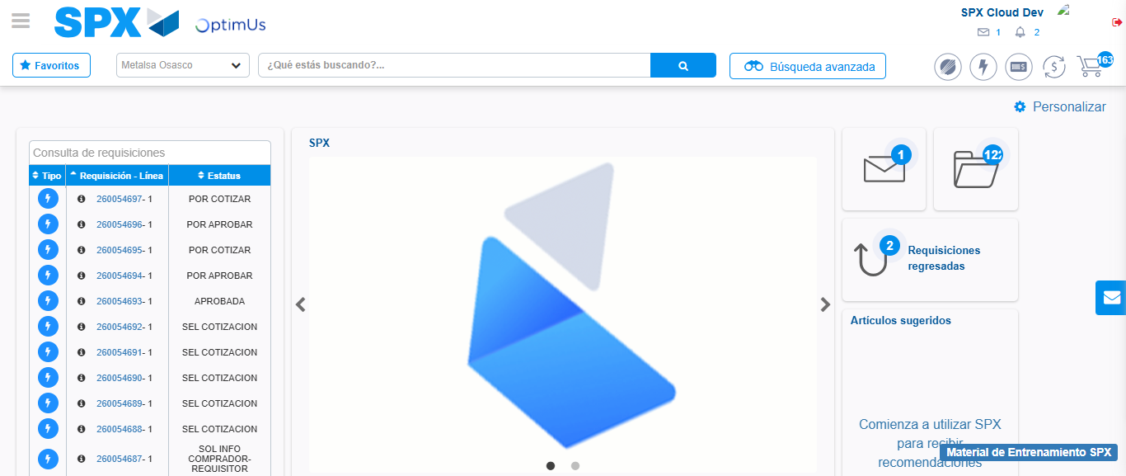Image file-name: QC_Testing-tc003_SPX_Dev5_Crear_Requisicion_Spot_Tipo_Cobro_CC_Urgent-1785961327408

